**Test Case 0009**

**System:** Bench

**Description:** Tests that the user is able to edit/personalize my calendar.

**Severity**: 3

**Instructions**

**Test 1**

1. Start the Bench application.
2. Click the button “Login” on the navigation bar.
3. Enter the email “team23project@gmail.com” into the text field labeled “Email address”.
4. Enter the password “12345678” into the field labeled “Password”.
5. Click the button “Login” below the field.
6. Open the event calendar using the My Event button on the navigation bar
7. Enter “event” on the title field, and the current date on the content field
8. Press the “ADD EVENT” button

**Expected Result:** The user should see the new event created

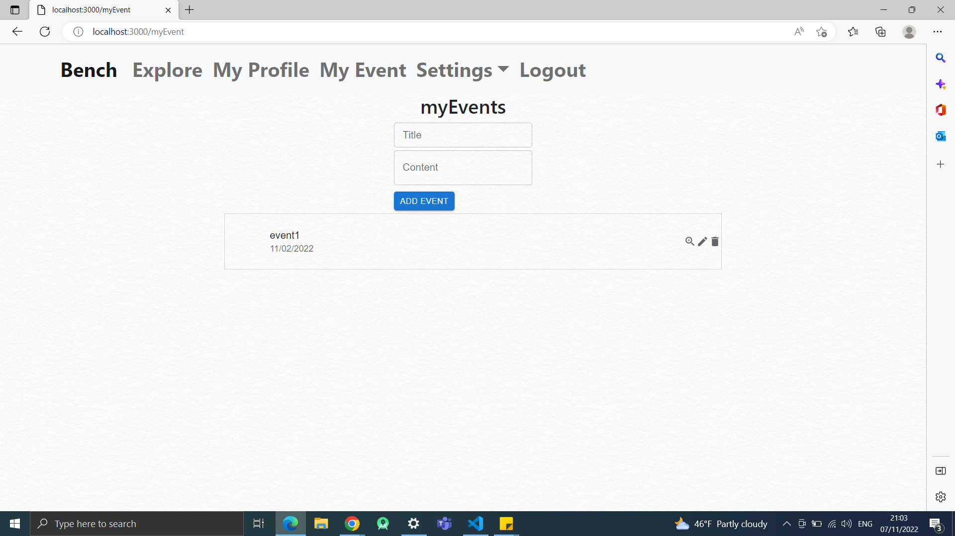

**Test 2**

1. Start the Bench application.
2. Click the button “Login” on the navigation bar.
3. Enter the email “team23project@gmail.com” into the text field labeled “Email address”.
4. Enter the password “12345678” into the field labeled “Password”.
5. Click the button “Login” below the field.
6. Open the event calendar using the My Event button on the navigation bar
7. Press the button that looks like a trash can on the event titled “event1”

**Expected Result:** The user should be unable to see “event1” event on the display.

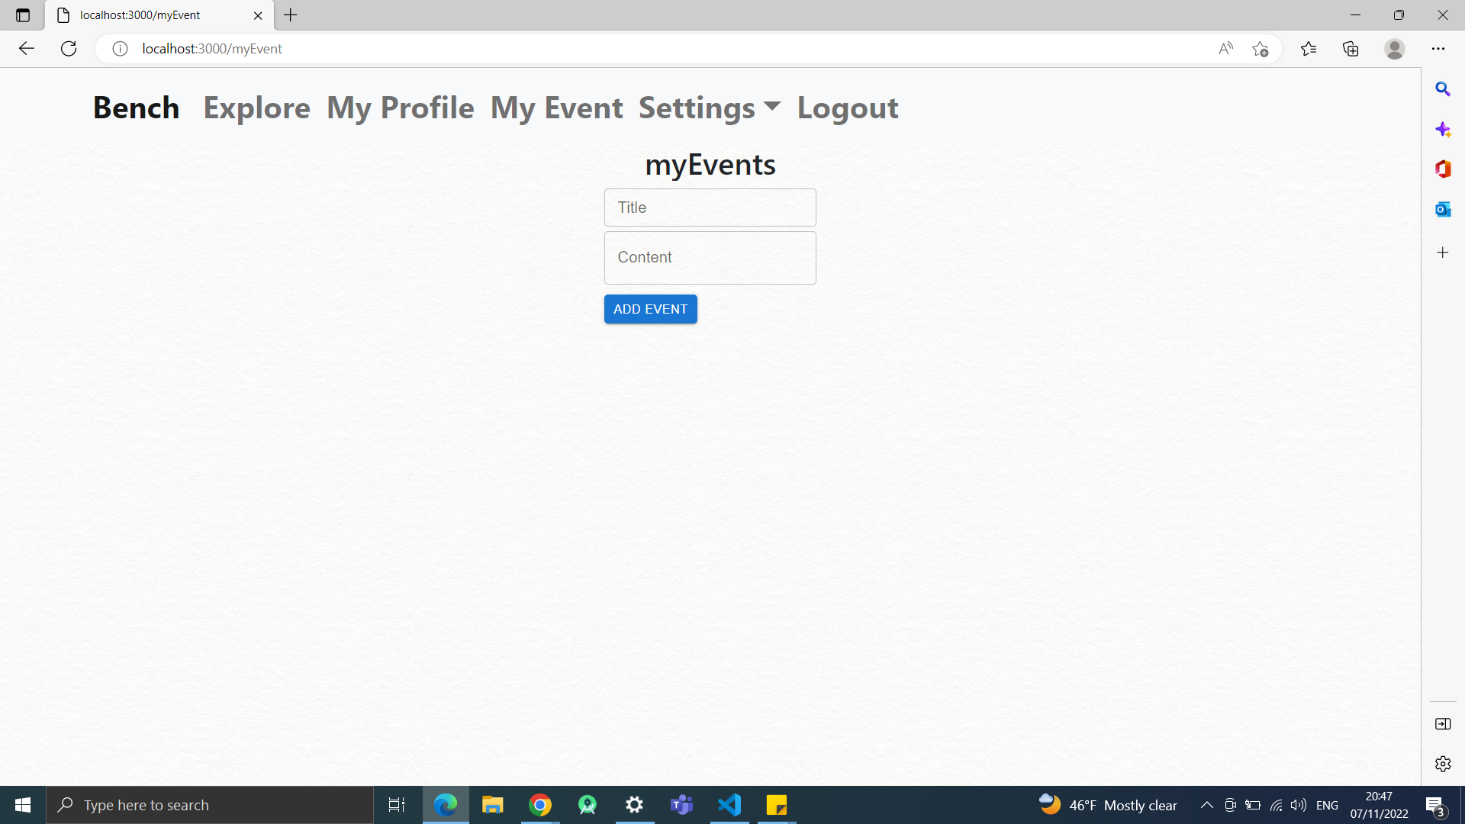

**Test 3**

1. Start the Bench application.
2. Click the button “Login” on the navigation bar.
3. Enter the email “team23project@gmail.com” into the text field labeled “Email address”.
4. Enter the password “12345678” into the field labeled “Password”.
5. Click the button “Login” below the field.
6. Open the event calendar using the My Event button on the navigation bar.
7. Enter “event4” on the title field, and the current date on the content field
8. Press the “ADD EVENT” button
9. Enter “event1” on the title field, and the current date on the content field
10. Press the “ADD EVENT” button
11. Enter “event2” on the title field, and the current date on the content field
12. Press the “ADD EVENT” button
13. Press the edit button on “event4” and change the title to “event3” and keep the content field as the current date
14. Press the “CHANGE EVENT” button

**Expected Result:** The user will create three events, change the first created event, which was originally at the bottom of the list, and will be on the top after the change, immediately.

